**CAR COUNTING SOFTWARE**

**INSTALLING VISUAL STUDIO**

* Download the most recent version of Visual Studio from the Microsoft website (choose the Community version which is free at the following website). <https://visualstudio.microsoft.com/it/downloads/>

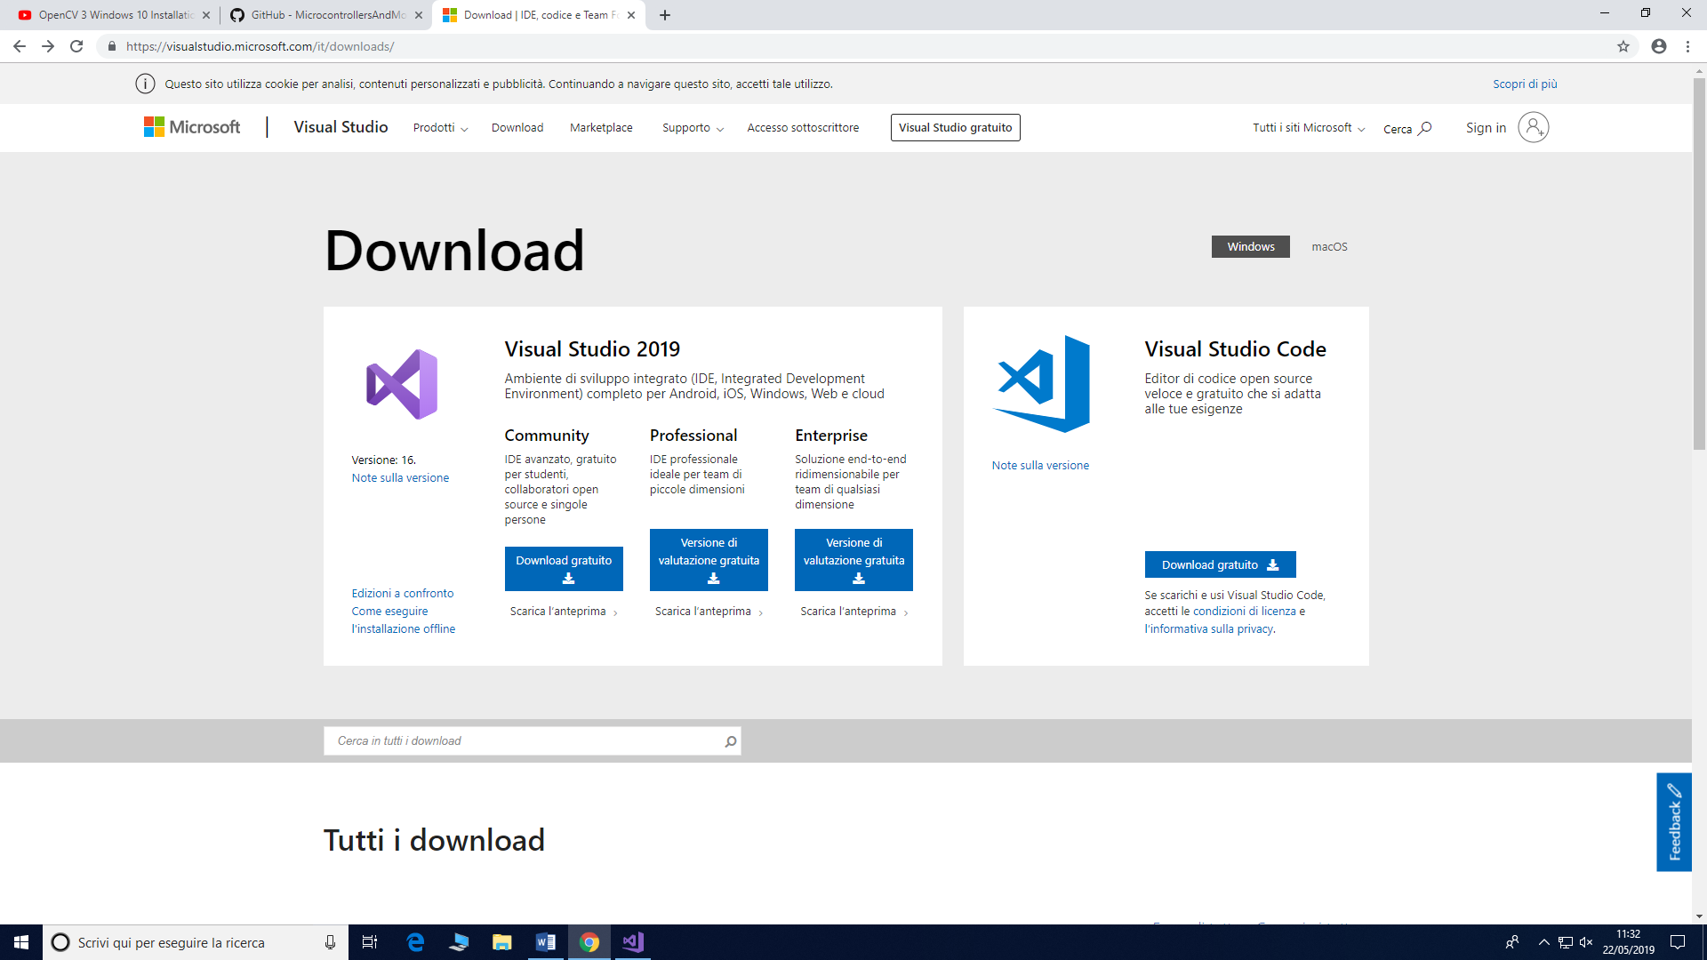

* Run the file and install the product with eventual additional components.
* In the section “Carichi di lavoro” (see the screen below), select “Sviluppo Pyton” and “Sviluppo di applicazioni desktop con C++”, and, therefore, start the installation.

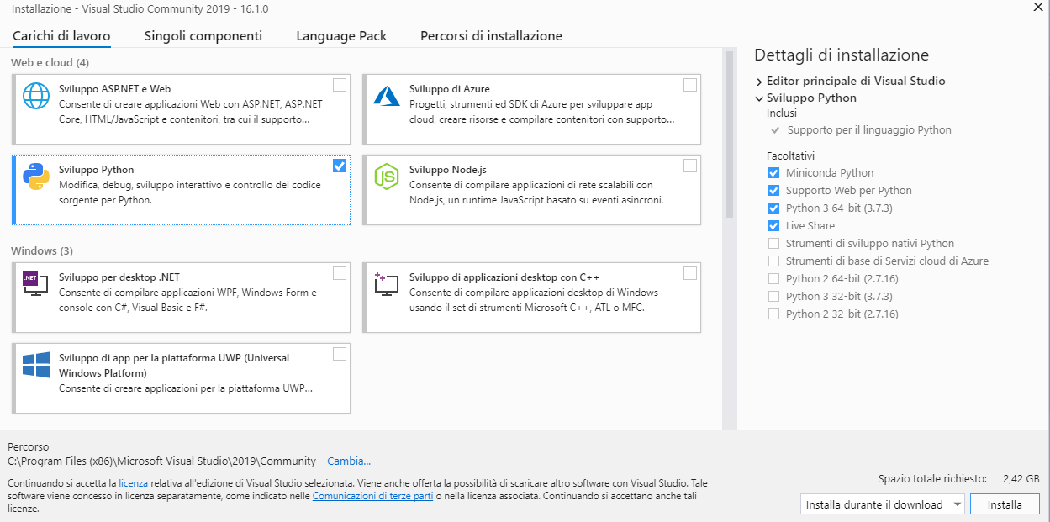

* Restart the pc to make available the modifies.
* Create an icon on the desktop of the software installed.
* Choose if create an account or not.
* Modify the aspect and the interface (if you wish). Select “Continue without code” on the bottom in the right part of the screen to start the software.

**INSTALL OPENCV**

* Copy the folder OpenCV 3.1.0 of this pc in the disk “C:\” (this step was referred to people working on the UNISA pc).
* Paste this folder in the disk “C:\” of your pc.
* Open a file .sln with Visual Studio.
* Eventually, install additional components if requested by the software.

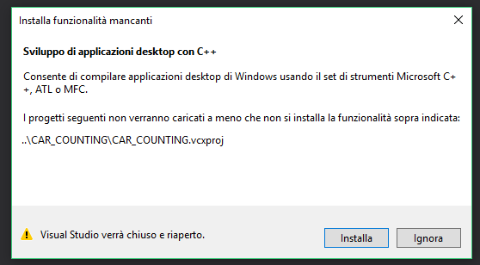

This window should not appear in case the components were already previously installed.

**CONNETT OPENCV TO VISUAL STUDIO (**<https://www.youtube.com/watch?v=7SM5OD2pZKY>)

After having opened a file .sln with Visual Studio, perform the following actions:

* In the **General** section, set the operating system, and the Visual Studio version you are using.

Click on “Project” (“Progetto”), select “*file_name* Properties…”;

* In the section **VC++ Directories**:
  + - click on **Include Directories**, select**<Edit…>** and digit:

*C:\OpenCV-3.2.0\opencv\build\include*

* + - click on **Library Directories**, select **<Edit…>** and digit:

*C:\OpenCV-3.2.0\opencv\build\x64\vc14\lib*

* In the section **Linker**, and select the subsection **Input**:
  + - Click on **Additional Dependencies**, select **<Edit…>**, and digit:

*opencv_world320d.lib*

* Click on “Apply” and then on “Ok”.

Modify the value “Debug” at the top of the screen by substituting it in “Release”.

* In the **VC++ Directories**:
  + - Click on **Include Directories**, select **<Edit…>** and digit:

*C:\OpenCV-3.2.0\opencv\build\include*

* + - Click on **Library Directories**, select **<Edit…>**, and digit:

*C:\OpenCV-3.2.0\opencv\build\x64\vc14\lib*

* Click on **Linker**, select the subsection **Input**:
  + - Click on **Additional Dependencies**, select **<Edit…>**, and digit

*opencv_world320.lib (*be aware that comparing the process done for Debug, in Release it misses a d in this extension).

* Click on Apply and then on Ok.

**(Important) Modify the value“x64” at the top part of the screen, by substituting it with “x86”, and then repeat the same procedure above described both for “Debug” and “Release”.**

After having done that, change “x86” e “Release” at the top part of the screen, respectively choosing “x64” e “Debug”.

Go to Control Panel, System and security, then System, and select “Advanced”, then “Environment variables” and in the **bottom** list select “Path”.

Click on Modify and then select the path: *C:\OpenCV-3.2.0\opencv\build\x64\vc14\bin*

Click on Ok.

Save the .sln file by clicking on “File” and then on “Save all”.

Starting from now, it will be possible to open any file .sln without repeating this procedure.

To open a .sln file, start Visual Studio, in the File section, select Open, then Project/Solution. Alternatively, open with a double click of the mouse.

To open the source code, click on the trigger located on the left side, then click on **Source Files, and double click on** “main.cpp”.

To run the code, click on the green arrow **Debugger Windows locale**.

To insert a different video, rename it in “CarsDrivingUnderBridge.mp4” and put it in the subfolder where the videos are located.

N.B. If you use other versions of **OpenCV**, substitute the part “OpenCV-**3.2.0**” with the extension of the version you have.

N.B. If you are not able to open the .sln file, try to move it on the desktop, or at least in the same disk where Visual Studio is installed.

**CODE**

Modify these parameters to translate or rotate the lines:

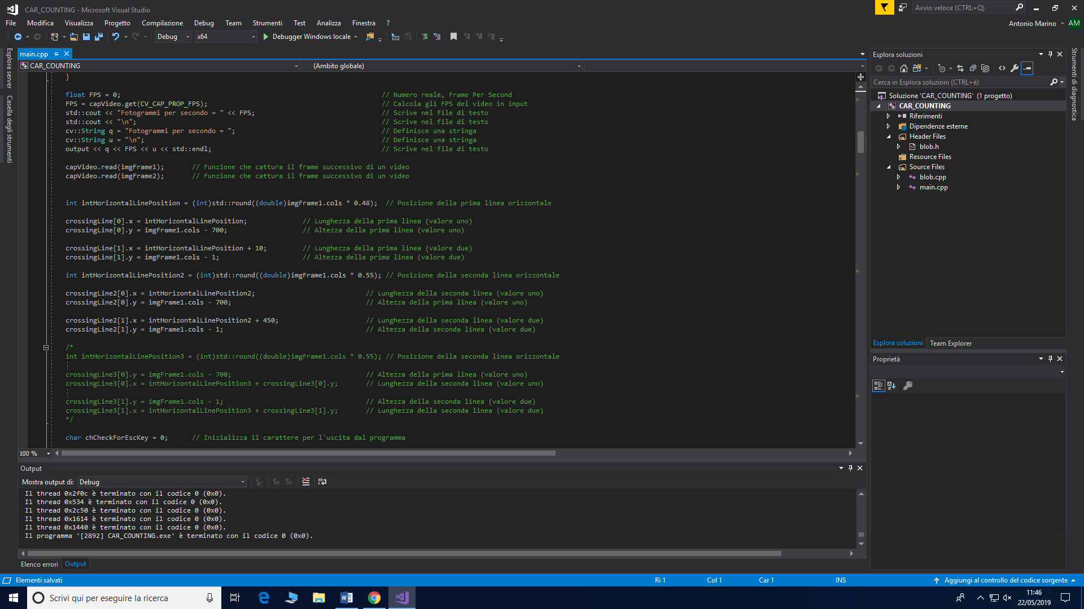

Modify the extreme of this “for” cycle to enlarge or reduce (in a proportional way) the resolution of the video, in order to reduce the false positives.

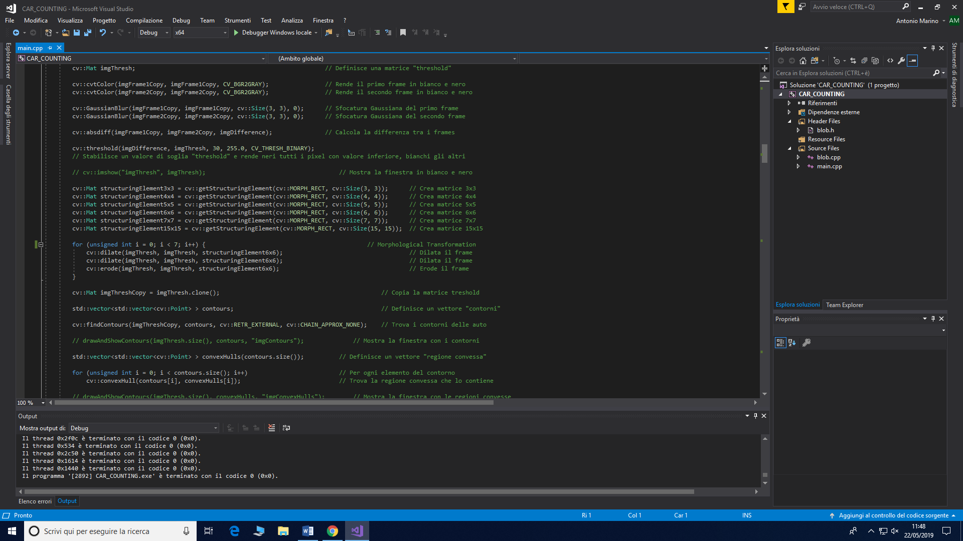

Comment this row (with “//”) in order to let the video run automatically, otherwise, it will be run frame per frame by clicking on any taste of the keyboard.

